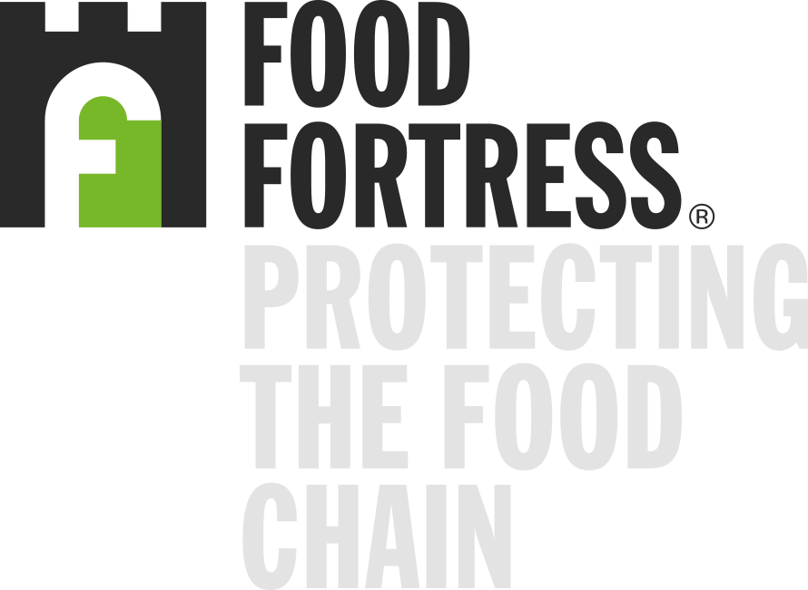
Cefetra Ltd.
is an importer member of the Food Fortress contaminant surveillance program for animal feeds.
Signed
Dr Keith Agnew  Chief Executive Food Fortress | Professor Sharon Huws    Director Institute for Global Food Security,    Queen’s University Belfast

Dated - 1st July 2026 (valid for 12 months)

